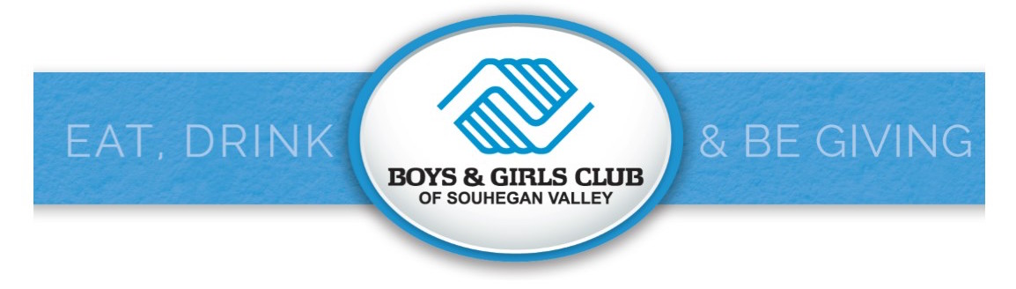
ANNUAL FUNDRAISING AUCTION – November 18, 2017
Sponsor / Advertiser / Table Reservation Form
Use this form or visit: www.svbgc.org/auction
BUSINESS NAME (as it should appear in program) | CONTACT NAME
ADDRESS | TITLE
CITY / STATE / ZIP | PHONE
EMAIL | CELL or other alternate contact method
SPONSORSHIP LEVEL – check one:  - $10,000 DREAM SPONSOR  - $7,500 CHARACTER / CITIZENSHIP SPONSOR  - $5,000 HEALTHY LIFESTYLES SPONSOR  - $2,500 ACADEMIC SUCCESS SPONSOR  - $1,000 YOUTH SPONSOR  - $500 CIVIC SPONSOR  Commitment deadline for inclusion in event program and other print materials: November 1, 2017 | AD ONLY - Black / White  - $500 FULL PAGE 7.5” x 4.5”  - $300 HALF PAGE 3” x 4.5”  - $200 QUARTER PAGE 3.5” x 2”  Submit as Adobe Acrobat 300 dpi files by November 1, 2017 in order to be included in the event program.  Email to: amorgan@svbgc.org
TABLES / TICKETS ONLY  - Table for ten $1,250  OR  - _____ seats at $125 each $_________ | PAYMENT OPTIONS  - Enclosed is a check for $_________________ OR  - Please charge my credit card for $_______________  ___VISA ____ M/C ____ Discover ____AMEX  Card Number: ______________________________________  Expiration: _____/______ Security Code: _______  Signature:__________________________________________
Boys & Girls Club of Souhegan Valley ∙ P.O. Box 916 ∙ 56 Mont Vernon Street ∙ Milford ∙ NH ∙ 03055
603-672-1002 ext. 12 or 23

